**Task 1:-Basic Network Sniffer**

* Build a python program to capture network traffic packets:
* **Install python3 pip**

* **Install scapy**

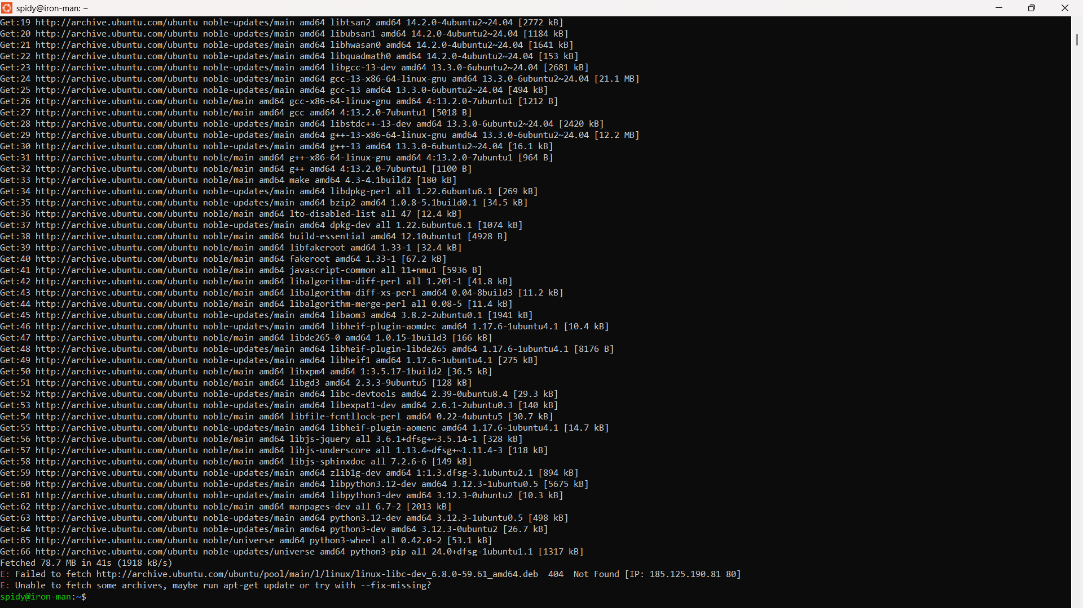

* **Change to a different mirror**

software-properties-gtk

Under the "Ubuntu Software" tab, change the Download from to "Main server" instead of a local mirror.

* **Use a Virtual Environment**

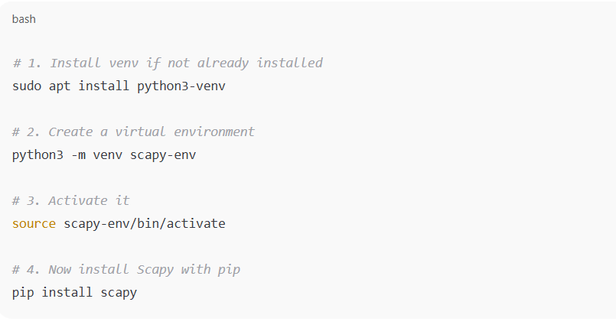

* **Activate your virtual environment**

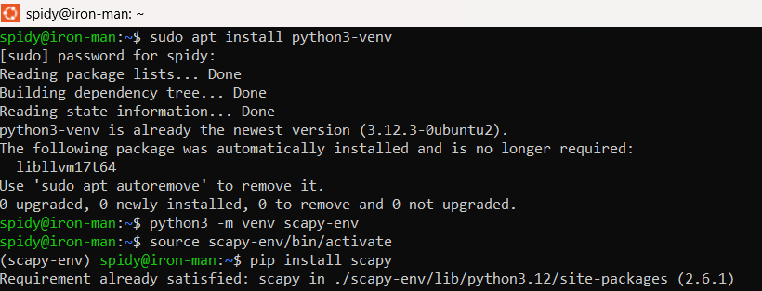

* **Create the Python File**

nano task1.py

Then type the python program to

* **Run the Script with Root Permissions**

sudo python3 task1.py

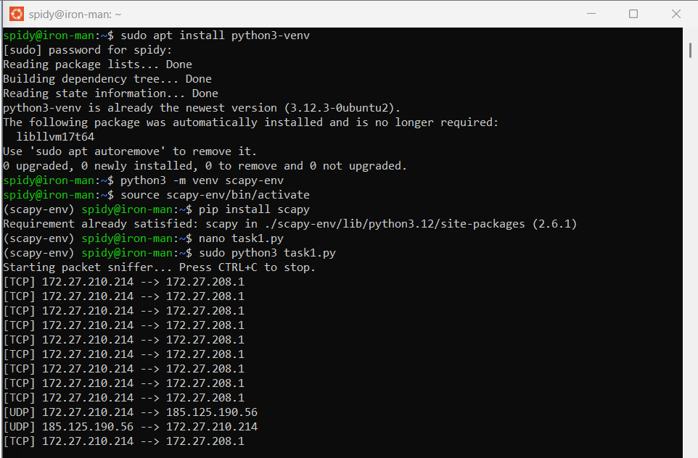

* **Create another Python File**

nano sniffer.py

Then type the code

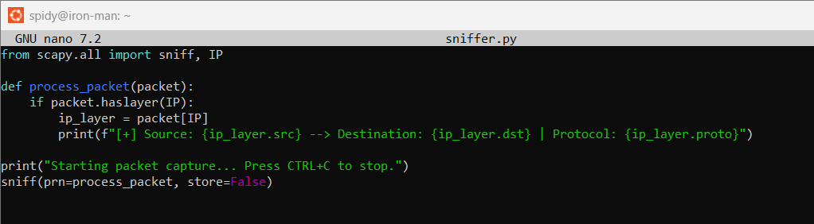

* **Run the Script with Root Permissions**

sudo python3 sniffer.py

